**Assignment 2**

**Task1**

**a)**

4 States:

1. Resting state (not being touched)
2. Scrolling forward (rotating the wheel forward)
3. Scrolling backward (rotating the wheel backward)
4. Pressed down (wheel click)

6 Actions:

1. Rotate forwards: Rotating the scroll wheel upwards. (start and stop)
2. Rotate backwards: Rotating the scroll wheel downwards. (Start and stop)
3. Press: Pressing down on the scroll wheel. (press and release)

**b)**

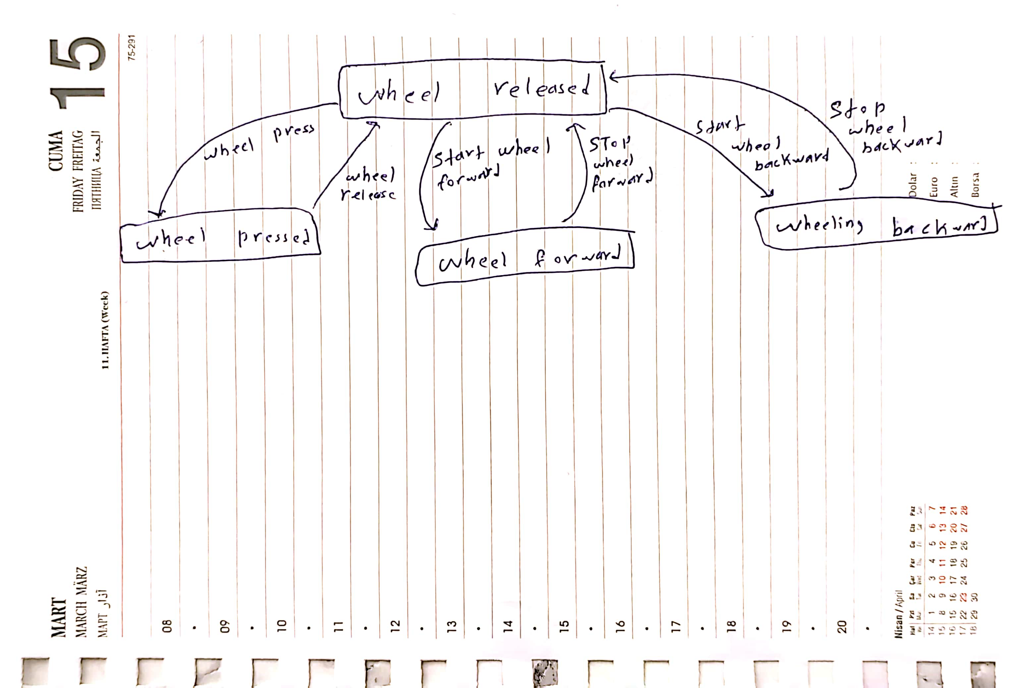

**Task 2**

Degree of indirection refers to the spatial and temporal offsets generated by a GUI element.

* For a menu, the degree of indirection is high.
* Dialog boxes typically have a high degree of spatial and temporal indirection.
* Handles for graphical editing have a low degree of indirection.

Degree of integration measures the efficiency of controlling a GUI element, comparing the degrees of freedom provided by the element's logical part to those captured by the input device.

* The degree of integration for menus ranges from low to medium depending on the type.
* Dialog boxes have low degree of integration.
* Handles for graphical editing often have a high degree of integration.

Degree of compatibility measures how well the physical actions of users on the instrument match the response of the object.

* Menus typically has a low degree of compatibility.
* Dialog boxes have low degree of compatibility.
* Handles have high degree of compatibility.

**Task 3**

(a) For achieving a fast response speed for multiple buttons, based on the results of the experiments, a button size of at least 16.51 mm^2 square would be suitable. This size allows for relatively quick reaction times while maintaining accuracy. As for the individual buttons, size 11.43 mm^2 would be enough.

(b) For spacing between buttons when several buttons are arranged next to each other, a spacing of 3.17 mm^2 to 12.7 mm^2 would be suitable based on user preferences and performance. This spacing allows for efficient touch interactions while providing enough separation between buttons to minimize errors. Usually, participants choose 6.35 mm^2. If the spacing is too large, it can increase the time for users to search the screen and touch the target button, leading to slower interaction times and potentially lower accuracy.

(c) Two examples of graphical user interfaces suitable for all age groups, including older adults, could be:

1. A weather application with large touch buttons for accessing different features like current conditions, forecasts, and radar maps. The buttons could be appropriately sized and spaced for easy interaction.
2. A medication reminder app with clear, large buttons for setting reminders, viewing medication schedules, and confirming doses. Again, the buttons should be designed with consideration for older adults' needs.

When designing for all age groups, it's essential to consider the specific needs and abilities of older adults, especially regarding manual dexterity and visual acuity. Therefore, the design should primarily consider the needs of older adults while ensuring usability for users across different age groups.